

**WOX7001 Research Methodology**

**2/2021/2022**

**<CASE STUDY OF VARIOUS RESEARCH METHODS>**

**Group assignment**

**Group Members:**

| Name: | Matric Number: |
| --- | --- |
| YOUSEF HOSNY ELSAYED | S2141806 |
| NUR SHAFIQAH BINTI MUHAMAD BAHARUM | S2151950 |
| VICKNESWARY PERUMAL | S2150313 |
| FIRDAUS | 17220599 |
| ZHANG ZITENG | S2149768 |

# **Research Methodology Study**

1. Varady et al. 2015 used experimental study to study the effect of weight loss via high fat vs. low fat alternate day fasting diets on free fatty acid profile. Participants were recruited from the Chicago area and were randomized by stratified random sampling based on BMI and age. Potential participants were eligible if they were female, 25 to 65 years of age, with a body mass index (BMI) between 30 and 39.9 kg/m2. Participants had to be weight stable for 3 months prior to the beginning of the study, sedentary or lightly active, non-smokers, non-diabetic, and not taking any medications. All volunteers provided written informed consent. All study protocols were carried out in accordance with guidelines approved by the Office for the Protection of Research Subjects at the University of Illinois at Chicago, Chicago, USA and the Human Research Ethics Committee at Concordia University, Montreal, Canada. After a 2-week weight maintenance period, 29 women (BMI 30–39.9 kg/m2 ) 25–65 years old were randomized to an 8-week alternate day fasting (45% fat) diet or an alternate day fasting (25% fat) diet with 25% energy intake on fast days and ad libitum intake on feed days. Body weight, BMI and waist circumference were assessed weekly and body composition was measured using dual x-ray absorptiometry (DXA). Total and individual plasma free fatty acid and plasma lipid concentrations were measured before and after weight loss. All data was analyzed using SPSS software. Results were presented as mean +- standard error of the mean (SEM). Normality was assessed by Shapiro-Wilks tests. Independent samples t-tests were used to test baseline differences between groups. Repeated-measures ANOVA were used to assess for significant differences with time as the within-subject factor and diet as the subject factor. Post-hoc analyses were done using a Tukey’s test. Pearson correlations were performed to assess the relationships between body composition and FFA concentrations. differences were considered significant at P , 0.05. It was found that In the alternate day fasting (low fat) group, decreases were found in several more free fatty acids than in the alternate day fasting (high fat) group. In the alternate day fasting (high fat) group, free fatty acid concentrations were positively correlated with waist circumference.
2. Lobene et al. (2021) conducted an experimental student to quantitatively measure the impact of time restricted eating on bone mineral density. The problem statement is that short-term TRE studies show no effect on bone mineral density (BMD), but no study has measured bone turnover markers. This experimental study examined the effect of 12 weeks of time restricted eating vs. unrestricted eating on bone turnover and BMD. overweight and obese adults aged 18–65 y (n = 20) were randomized to time restricted eating (TRE - ad libitum 8-h eating window) or non-time restricted eating. Serum N-terminal propeptide of type I collagen (P1NP), cross-linked N-telopeptide of type I collagen (NTX), and parathyroid hormone (PTH) levels were measured and dual-energy X-ray absorptiometry (DXA) scans were taken pre- and post-intervention to measure and analyze the bone mineral density in the two groups, the findings of the experiment suggest that TRE does not adversely affect bone over a moderate timeframe. Further research should examine the long-term effects of TRE on bone.
3. Currenti et al. (2021) used face to face interviews and electronic data collection using tablet computers to investigate the association between the timing of the feeding period and cognitive status in a cross-sectional cohort of adults living in the Mediterranean area. Before conducting the interview, aims of the study were introduced to all participants and informed written consent was obtained. The study protocol was reviewed and approved by the concerning ethical committee and all the study procedures were carried out in accordance with the Declaration of Helsinki (1989) of the World Medical Association. Demographic and dietary characteristics of 883 adults living in Southern Italy (Sicily) were analyzed. Food frequency questionnaires were used to calculate the time window between the first and the last meal of an average day. In order to assess the dietary intake, two food frequency questionnaires (FFQ, a long and a short version) were taken. Participants with an eating time window duration of more than 10 h were then identified, as well as those with eating time restricted to less than 10 h time restricted feeding (TRF). The relation between exposure variables and cognitive status was tested through multivariate logistic regression analysis adjusted for baseline characteristics (age, sex, marital, educational and occupational status, smoking and alcohol drinking habits, and physical activity level). All reported p values were based on two-sided tests and compared to a significance level of 5%. After adjusting for potential confounding factors, individuals adherent to TRF were less likely to have cognitive impairment, compared to those with no eating time restrictions.
4. Godar et al. (2015) conducted an experimental study to find if there is any relationship between intermittent fasting and myocardium Ischemia-Reperfusion Injury prevention. Adult mice were housed in groups of up to n=5 mice/cage and fed standard chow (Lab Diet, 5053; providing 3.4Kcal/g with 62.1% Kcal derived from carbohydrates, 13.2% from fats, and 24.6% from protein) on a 6:00PM to 6:00AM night-day cycle, while housed on cedar pine chip bedding. Intermittent fasting was performed with total food deprivation and ad libitum access to water from 12:00PM to 12:00PM of the following day to implement alternate periods of 24 h fasting and feeding, with change in bedding. Nonfasted control mice were simultaneously provided fresh food with change in bedding. Daily food intake per cage was weighed to calculate average daily food intake per mouse. Mice were weighed at weekly intervals on fed days. Terminal studies on mice were initiated between 8:00 to 10:00 AM after an overnight period of feeding (i.e., on a fed day). Godar et al. (2015) tested their hypothesis ‘that intermittent fasting protects against myocardial ischemia-reperfusion injury’ via transcriptional stimulation of the autophagy-lysosome machinery. It was found that adult C57BL/6 mice subjected to 24-h periods of fasting, every other day, for 6 weeks were protected from in-vivo ischemia-reperfusion injury on a fed day, with marked reduction in infarct size in both sexes as compared with nonfasted controls.
5. Cienfuegos et al., 2021 conducted an experimental study of an 8-week TRF study (4–6 h eating window, 18–20 h fasting window daily) on adult women with obesity which was divided into two groups based on the menstrual status premenopausal and postmonopausal. The result shows that premenopausal and postmenopausal women lose equivalent amounts of weight (~3% from baseline) and experience similar body composition changes during TRF. Their findings also show that key metabolic risk factors, such as fasting insulin, insulin resistance, and 8-isoprostane (marker of oxidative stress), improve similarly in these groups of women. Taken together, these data suggest that the weight loss and metabolic benefits of TRF do not vary according to menopausal status. These preliminary findings warrant confirmation by a well-powered clinical trial that specifically aims to assess how menopausal status impacts changes in body weight and metabolic risk factors during TRF.
6. Peeke et al., 2021 between June and October 2020, an experimental investigation of 8-week, randomised, controlled clinical trials involving men and women (BMI 30 kg/m2) was undertaken. The research was carried out remotely. Participants were assigned to 14:10 or 12-hour TRE (12:12, active comparator) and given a diet and exercise programme that included weekly tailored counselling and support. They aim to see which group will lose the most weight between TRE 14:10 and TRE 12:12 which were also combined with the commercial weight management program. They also wanted to investigate the effect of the low-calorie, high-fat, low-carbohydrate, and low-protein “fasting snack” on blood glucose. To collect the data, the participants were given an instructional video that should be followed like step-by step demonstrations for all study procedures during the process. Later, the participants send the data through the system in their gadgets to the researchers like body weight and blood glucose level on a weekly basis and 2 days per week respectively. The result shows that in participants with obesity who completed 8 weeks of the 14:10 TRE schedule combined with a commercial weight loss program, there was statistically significant and clinically meaningful weight loss and improvements in fasting blood glucose (FBG).
7. Jamshed et al. 2019 conducted an experimental study to investigate that TRF has an impact on gene expression, circulating hormones, and diurnal patterns in cardiometabolic risk factors for humans. To get the information, the researchers recruited eleven obese people to took part in a 4-day randomised crossover research in which they ate between 8 a.m. and 2 p.m. (early TRF (eTRF)) and 8 a.m. and 8 p.m. (late TRF (control schedule). To collect data like glucose level, the participants were using tools like continuous glucose monitor (GCM) which was inserted under the skin into the subcutaneous fat of the abdomen. These tools can automatically send data to the system. Blood was taken from participants to measure cardiometabolic risk factors, hormones, and gene expression in whole blood cells. The results show that eTRF improves a variety of health outcomes through both circadian and fasting-related mechanisms. By lowering 24-hour glucose levels, reducing glycemic excursions, and maybe increasing insulin signaling, eTRF improves glycemic control. Importantly, some of these reductions in glycemic excursions may be fueled not just by eating earlier in the day but also by having a short inter-meal interval, implying that TRF therapies with longer inter-meal intervals may be less efficient at lowering glucose levels. They also discovered that eTRF affects diurnal patterns in fasting cholesterol, ketones, cortisol, and circadian clock genes; in particular, it raises morning ketone levels and improves the amplitude of the cortisol rhythm. Finally, eTRF has a positive impact on longevity and autophagy-related hormones and genes.
8. Currenti et al., 2021 conducted a study to investigate the relationship between the feeding/fasting time window and metabolic outcomes among adult individuals. To extract the information, 1936 adult subjects living in the south of Italy were examined. Food frequency questionnaires (FFQ) were used to determine the time between a typical day's first and last meal. Subjects then divided into three groups with a time feeding window lasting more than 10 h, within 8 h (TRF-8) and within 10 h. To collect the data, they did several tests like metabolic outcomes, dietary assessment and time feeding assessment. They discovered that people who ate their food in a window of 8 or 10 hours were less likely to be fat and overweight, to have hypertension, and to have dyslipidemia. Individuals with different meal times did not differ in total calorie intake or other critical nutrients that could have thrown the analyses off, implying that the possible effects of time-restricted feeding are not related to energy or nutrient disparities across groups. They concluded that metabolic diseases may be implying that changes in feeding/fasting length may play a role in general population daily routines. According to the findings of this study, time-restricted feeding may play a role in the prevalence of metabolic consequences like being overweight/obese and having hypertension.
9. Thomas et al., 2022 conducted a study to compare the acceptability and efficacy of early time-restricted eating plus daily caloric restriction (E-TRE+DCR) within a behavioural weight-loss intervention to DCR alone. They compared the acceptability and efficacy of a 39-week weight-loss intervention using E-TRE+DCR to DCR in adults who were overweight or obese. Unlike the majority of short-term studies that found metabolic benefits with TRE, most free-living trials of TRE allowed participants to self-select eating windows to increase adherence. They did, however, want to see if a prescribed early eating window was acceptable in the context of behavioural weight-loss intervention. Overall, they found E-TRE+DCR to be satisfactory, with no differences in class attendance, attrition, or self-reported adherence between the E-TRE+ DCR and DCR groups. At 12 weeks (5.1 kg or 5.5 percent and 6.2 kg or 6.3 percent, respectively) and 39 weeks (4.3 kg or 4.7 percent and 4.9 kg or 5.2 percent), their results show similar weight loss in the DCR and E-TRE+ DCR groups. Previous studies of TRE without caloric restriction or behavioural support found variable but overall modest weight loss (1–4%). (1-9). In contrast, adding behavioural support and caloric restriction recommendations to a TRE intervention results in clinically significant (>5%) weight loss. We gave calorie goals to both groups in this trial, but we discovered early on that participant in the E-TRE+ DCR group had difficulty focusing on both calories and eating windows. As a result, we asked the E-TRE+ DCR group to prioritise eating windows over calorie reduction. Participants in the E-TRE+ DCR group reported higher adherence to eat within their windows when compared to eating at or below their calorie goals.
10. Światkiewicz, Mila-Kierzenkowska, et al. 2021 presented quantitative research and the field experimental technique on the effects of a 14-hour TRE intervention on metabolic, neuroendocrine, inflammatory, and oxidative stress, as well as cardiac standard parameters in Polish adults (18-75 years), and they are still recruiting participants. The study's primary goal was to collect large amounts of data using the myCircadianClock mobile software in order to conduct a randomised controlled trial to determine the effect of long-term TRE on cardiometabolic health in the MeTS population. The myCircadianClock application and questionnaires will track dietary intake, sleep, activity, and well-being. The primary outcome is adherence to TRE, defined as the proportion of days recorded with the app during the monitored intervention in which participants satisfied 10-h TRE. TREMNIOS will also provide a preliminary framework for depicting post-TRE changes in cardiometabolic outcomes and behavioural rhythms. This protocol builds on previous TRE-related protocols by focusing on a European population with diagnosed MetS and incorporating long-term intervention, validated tools for monitoring dietary intake and adherence, and a wide range of biomarkers. TREMNIOS will lay the groundwork for a large-scale randomised controlled trial to determine the efficacy of TRE in improving cardiometabolic health in MetS patients.
11. An experimental design carried out by (Peters et al. 2021) in their research paper titled “Effects of Early vs. LateTime-Restricted Eating on Cardiometabolic Health, Inflammation, and Sleep in Overweight and Obese Women: A Study Protocol for the ChronoFast Trial” published in frontiers in Nutrition 2021. The ChronoFast trial study's goal is to see if eTRE or lTRE is a better dietary approach for improving cardiometabolic health with minimal calorie deficits and nearly stable body weight. They proposed a study protocol to investigate the effects of eTRE (8:00-16:00) and lTRE (13:00-21:00) on insulin sensitivity, blood sugar, and blood lipids in female obese patients. Its research aims to validate three assumptions. They first wanted to show that both modes of eating intervention improved blood sugar, metabolism, insulin sensitivity, and other factors. Second, they believe that diabetics will improve their blood sugar levels more effectively than non-diabetics. Human blood pressure, triglycerides, total and LDL cholesterol, and sleep quality may all suffer as a result. Finally, they hypothesised that the effects of the two approaches on the body's circadian rhythms would be diametrically opposed.
12. Park et al. 2021 conducted an experimental study to investigate the effects of 8 hours of TRE on body weight and cardiometabolic risk factors in young adults who were primarily active at night. 33 young adults completed the 8-hour TRE over the course of four weeks. Body composition was measured using bioelectrical impedance analysis at the start and every two weeks, and blood samples were taken at the start and week four. Throughout the intervention period, daily dietary records were kept. After 4 weeks of TRE, participants had significant changes in body weight (1.0 1.4 kg), body mass index (0.4 0.5 kg/m2), and body fat (0.4 1.9 percent). When participants were divided into weight loss/gain groups based on their weight change in week 4, the fat mass reduction in the weight loss group was significantly greater than in the weight gain group. In terms of cardiometabolic risk factors, levels of fasting insulin and insulin resistance improved in the weight loss group but not in the weight gain group following the intervention. All subjects had late-shifted sleeping patterns, but there were no significant differences between the two groups in sleep duration, sleep quality, or psychological measures. The average meal frequency was 2.8 0.5, and the energy proportions of breakfast, lunch, dinner, and snacks were 4.5, 39.2, 37.6, and 18.5 percent, respectively; there were no significant differences between the two groups. However, the weight loss group consumed less saturated fat at dinner (3.1 3.2 percent vs. 6.0 2.5 percent). The results of this four-week TRE dietary intervention suggest that TRE is an effective method for managing weight and cardiometabolic risk factors. Although the TRE regimen is not for everyone, it can be an effective lifestyle strategy for young adults with late chronotypes in terms of body weight and cardiometabolic risk factors.
13. Bjerre et al. (2021) conducted a longitudinal qualitative study based on semi-structured interviews with overweight or obese participants in a randomized controlled trial who were enrolled in a TRE intervention. Seventeen individuals were selected from the intervention group and two separate semi-structured interview sessions were conducted. Altogether 34 interviews were conducted at baseline and at the end of the intervention. A longitudinal approach was applied to investigate changes in the research sample from one-time point to the next. The collected data were analyzed using explorative and descriptive thematic analysis methods. First, to identify initial themes, the interview transcripts were analyzed and created relationships between data. Next, significant text units were discovered and coded. Then codes represented data features that were relevant to the analysis. So information that was assessed in a meaningful way about the real scenario. This procedure classified data into relevant groups and assigned content codes. The codes were then categorized into themes. Codes that overlapped were combined, and codes with insufficient intelligible text units were removed.
14. Flanagan et al. (2022) study used a mixed-method approach. They applied a cross-sectional quantitative and quasi-qualitative online survey study for women who were pregnant at the time of study completion or had given birth in the prior 2 years. The main purpose of the research was to investigate TRE effects on the metabolic response of pregnant women. To acquire quantitative data, an online questionnaire was created. They planned to gather information from a wide range of pregnant women. Thus, to engage the participants, they advertised on social media platforms, the research center's website, and via an email listserv and word of mouth. After successfully completing the survey, participants were given gift cards. Statistical analysis was performed using the Chi-squared analysis method based on a willingness to try a TRE pattern. Independent samples t-tests or analyses of variance were used to evaluate continuous variables. Qualitative responses of participants to the free-text box were reviewed by three reviewers.
15. Wilkinson et al. (2020) conducted an experimental research model to analyze the impact of time-restricted eating (TRE) on metabolic syndrome. Thirty-five participants diagnosed with metabolic syndrome were enrolled in this clinical study. The use of a smartphone application to capture real-time data about meal timing and sleep is used to monitor and intervene in the circadian aspects of lifestyle and its day-to-day variance. Participants were fitted with continuous glucose monitors (CGM) for glucose monitoring and a wrist-worn actigraphy device to assess sleep. On top of that, sleep data was also gathered from Pittsburgh Sleep Quality Index (PSQI) questionnaires. My circadian clock (mCC) app was used to record participants’ caloric intake from food, beverage, sleep, and exercise data. The collected datasets were analyzed using quantification and statistical analysis.
16. The research of Huang et al. (2021) investigates the effects of a 200-calorie fasting-mimicking diet (FMD) energy bar designed to extend ketogenesis and reduce fasting-related side effects. This paper approached a randomized, controlled parallel-arm study based on an experimental research methodology. Participants were recruited by email and internet ads, and data was collected via phone conversations and video conference calls. Electronic clinical trial management software was used to update and manage the data (CTMS). The trial was administered remotely in participants' homes rather than at a clinical trial site because it was conducted during the COVID-19 pandemic. Participants in this dietary intervention trial were randomly assigned to intervention groups and given interventions based on the study protocol. The participants were requested to complete an online survey as well as Likert Scale questions. They use statistical tools such as ANOVA with Tukey's and Scheffe's approaches for multiple comparison tests on data.
17. Naguib et al., 2022 conducted a quantitative study of the use of continuous glucose monitors (CGM) in conjunction with TRE to monitor patients' TRE performance and infer TRE window timing through a fixed-point trial. They invited 50 participants to perform the 12-week trial. All participants were required to wear the CGM for 13 consecutive weeks, and the CGM uploaded data every 5 minutes. The data of the first week are the data of the running-in period, and the data of the last 12 weeks are the comprehensive blood glucose data after TRE intervention. Based on the uploaded data, they performed a descriptive analysis of the data using the R language. They analyzed participant characteristics, the feasibility, safety, and acceptability of CGM, blood glucose profile fluctuations, and blood glucose fluctuations comparing TRE versus standard eating. The results suggest that CGM is a feasible aid that can be used to monitor subjects' TRE coverage. (Naguib et al., 2022)
18. Phillips et. al. 2021 conducted a randomized controlled trial of time-restricted versus standard eating in adults using quantitative studies and the field experimental technique. They first determined the screening criteria for the openly recruited population of trial participants. After the participants were recruited, they were randomized to record data using the TRE intervention or using the standard diet. Data recording is different from traditional questionnaires, interviews, etc. They use a smartphone app to take pictures of all consumed food, beverages and medicines for daily monitoring of the participants. This approach undoubtedly lended credibility to the process of data collection. Finally, the data was scientifically analyzed through python. The results suggested that a 12-hour TRE intervention was feasible in a broad population at 6 months. It also shows the potential of smart technologies for data collection and analysis in clinical scientific trials.(Phillips et al. 2021)
19. Parr et al., 2022 conducted a qualitative study on some of the problems faced by TRE and personal views on the future development of TRE by collating and aggregating a large body of literature on dietary strategies for TRE. The first domain of their research was the question of dietary strategies for improving metabolism. The second domain is the origin of TRE to human intervention. The third domain is that future TRE needs to improve the quality of dietary assessments. At this stage, they aggregated and collated different window time data on early, middle and late TRE intervention methods. In the next domain, they proposed that the role of TRE is not only to help lose weight. In the last domain, they proposed that TRE may be more acceptable to people than other dietary adjustment programs, and it is not easy to bring psychological pressure to people. The first two of these 5 domains are studies of the status of key TREs. The latter three are their personal views on TRE and related arguments. The results demonstrate the need for future research on TRE, the rigor of TRE data collection and evaluation, and the importance of standardized approaches to TRE interventions. (Parr et al., 2022)
20. Crose et al. 2021 conducted a quantitative analysis and research on "TRE can improve people's quality of life" through experimental technology. They invited 20 obese participants and divided them into a TRE group and a non-TRE group. Quality of life was assessed in 20 participants using the SF-36 (one of the most complete, reliable, and validated quality of life surveys) method after a period of TRE intervention, and the results were statistically analyzed. They used myCircadianClock, a professional smartphone app, for data collection. They chose the Experimental technique for the quantitative study because there is very little data on the effect of TRE on quality of life. There isn't enough real-world trial data to justify their claims. Compared with investigation documents, observation and other methods, Experimental is more reliable and more credible.After analyzing their trial data, they concluded that TRE had a positive effect on improving people's quality of life.(Crose et al. 2021）

# 

# **Comparison Table**

| ID & link | Group member | Author of article | Approach | Research Method |
| --- | --- | --- | --- | --- |
| [1](https://pubmed.ncbi.nlm.nih.gov/25557754/) | Yousef | Varady et al. 2015 | Experimental Study | Quantitative research |
| [2](https://doi.org/10.3390/NU13041155) | Lobene et al. 2021 | Experimental Study | Quantitative research |
| [3](https://doi.org/10.3390/nu13010191) | Currenti et al. 2021 | Interviewing | Quantitative research |
| [4](https://www.tandfonline.com/doi/full/10.1080/15548627.2015.1063768) | Godar et al. 2015 | Experimental Study | Quantitative research |
| [5](https://sci-hub.hkvisa.net/10.1016/j.exger.2021.111545) | Firdaus | Cienfuegos et al., 2021 | Experimental Study | Quantitative research |
| [6](https://sci-hub.hkvisa.net/10.1038/s41387-021-00149-0) | Peeke et al., 2021 | Experimental Study | Quantitative research |
| [7](https://doi.org/10.3390/nu11061234) | Jamshed et al., 2019 | Experimental Study | Quantitative research |
| [8](https://doi.org/10.3390/nu13010191) | Currenti et al., 2021 | Experimental Study | Quantitative research |
| [9](https://doi-org.ezproxy.um.edu.my/10.1002/oby.23420) | Shafiqah | Thomas, et al., 2022 | Experimental | Quantitative research |
| [10](https://doi.org/10.3390/nu13020346) | Światkiewicz, Mila-Kierzenkowska, et al. 2021 | Experimental & Apps questionnaire | Quantitative research |
| [11](https://doi.org/10.3389/fnut.2021.765543) | Peters et al. 2021 | Experimental | Quantitative research |
| [12](https://doi.org/10.3390/nu13072164) | Park et al. 2021 | Experimental | Quantitative research |
| [13](https://www-sciencedirect-com.ezproxy.um.edu.my/science/article/pii/S0195666321000465?via%3Dihubm.edu.my/science/article/pii/S0195666321000465?via%3Dihub) | Vickneswary | Bjerre et al., 2021 | Interview | Qualitative research |
| [14](https://doi.org/10.1093/jn/nxab397) | Flanagan et al., 2022 | Online questionnaire & Interview | Quantitative & Qualitative research |
| [15](https://doi.org/10.1016/J.CMET.2019.11.004) | Wilkinson et al., 2020 | Experimental | Quantitative research |
| [16](https://doi.org/10.3390/nu13051523) | Huang et al., 2021 | Experimental | Quantitative research |
| [17](https://doi.org/10.3389/FENDO.2022.841838) | Ziteng | Naguib et al., 2022 | Experimental | Quantitative research |
| [18](https://doi.org/10.3390/NU13031042) | Phillips et al. 2021 | Experimental | Quantitative research |
| [19](https://doi.org/10.1093/ADVANCES/NMAC015) | Parr et al., 2022 | Observation | Qualitative research |
| [20](https://doi.org/10.3390/NU13051430) | Crose et al. 2021 | Experimental | Quantitative research |

# Pie chart statistics

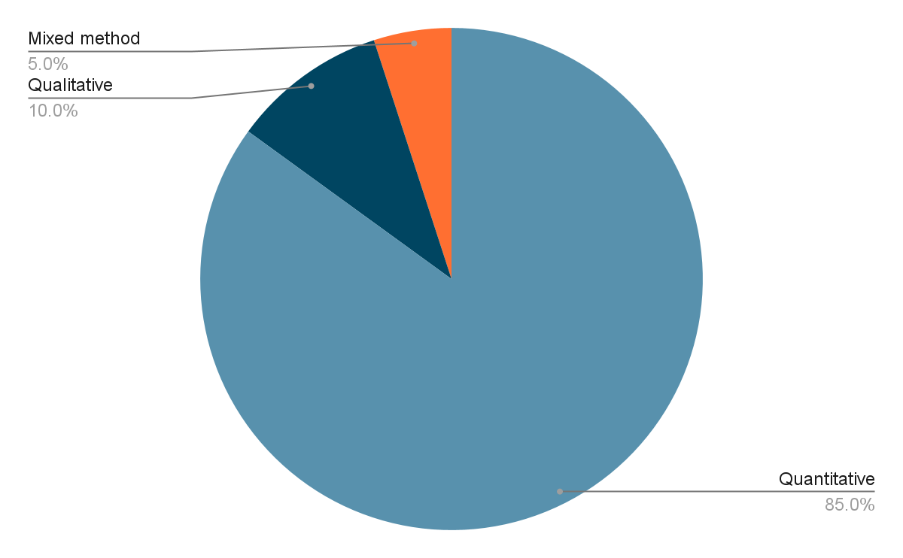

Figure 1: Research Method Approach Proportion

This pie chart illustrates the research methodology used on the above mentioned articles. This study's literature research methods are mixed method, qualitative, and quantitative. This pie chart gives an overall view of the various types of methods used in research articles. The majority of the articles employ a quantitative design, which represents 85% of the total research methods. Meanwhile, qualitative design makes up for 10% of the total, with mixed methods recording for the remaining 5%. This point is clearly emphasized by its visual separation from the rest of the pie. This demonstrates that the quantitative method is the most widely used analytical method in research papers. This proves that the quantitative method is the most adequate for these types of research studies.

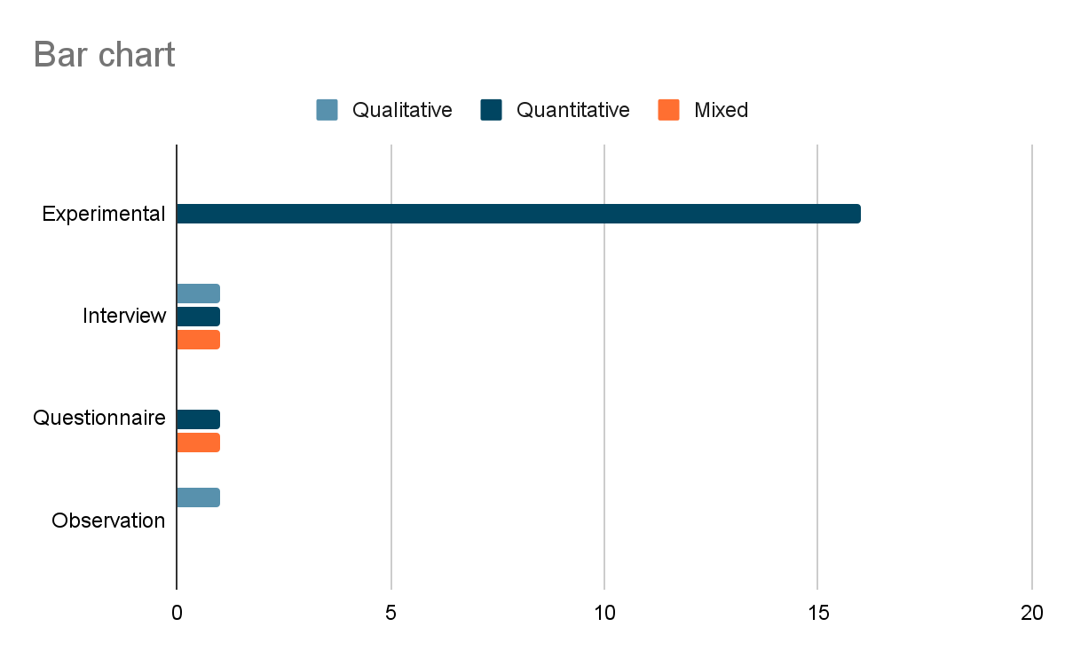

Figure 2: Bar chart describing different research method approaches

# 

As observed in Figure 2, most of the research approach that is most widely used in our papers is experimental study (16 research papers), most of the experimental studies were conducted on humans to examine the impact of restricted time eating, for example (Varady et al. 2015) examined the impact of restricted time eating on free fatty acids concentration levels. One experimental study was conducted on mice and found that restricted time eating prevents myocardial Ischemia-Reperfusion Injury from occurring. We can also observe that the Interview research approach was conducted one time in a quantitative research, 1 in a qualitative research method and 1 time in a mix-mode research. Moreover the questionnaire approach was conducted only twice in our collection of papers, 1 time in quantitative research and 1 time in qualitative research. Finally, the observation research approach was conducted only once in a quantitative research.

# **Reference**

1. Bjerre, N., Holm, L., Quist, J. S., Faerch, K., & Hempler, N. F. (2021). Watching, keeping and squeezing time to lose weight: Implications of time-restricted eating in daily life. Appetite, Volume 161, <https://doi.org/10.1016/j.appet.2021.105138>
2. Cienfuegos, S., Gabel, K., Kalam, F., Ezpeleta, M., Lin, S., & Varady, K. A. (2021). Changes in body weight and metabolic risk during time restricted feeding in premenopausal versus postmenopausal women. Experimental Gerontology, 154. <https://doi.org/10.1016/J.EXGER.2021.111545>
3. Crose, A., Alvear, A., Singroy, S., Wang, Q., Manoogian, E., Panda, S., Mashek, D. G., & Chow, L. S. (2021a). Time-Restricted Eating Improves Quality of Life Measures in Overweight Humans. Nutrients, 13(5). <https://doi.org/10.3390/NU13051430>
4. Currenti, W., Buscemi, S., Cincione, R. I., Cernigliaro, A., Godos, J., Grosso, G., & Galvano, F. (2021, May 13). Time-Restricted Feeding and Metabolic Outcomes in a Cohort of Italian Adults. nutrients. <https://sci-hub.hkvisa.net/10.3390/nu13051651>
5. Currenti, W., Godos, J., Castellano, S., Caruso, G., Ferri, R., Caraci, F., Grosso, G., & Galvano, F. (2021). Association between time restricted feeding and cognitive status in older italian adults. Nutrients, 13(1), 1–11. <https://doi.org/10.3390/nu13010191>
6. Flanagan, E. W., Kebbe, M., Sparks, J. R., & Redman, L. M. (2022). Assessment of Eating Behaviors and Perceptions of Time-Restricted Eating During Pregnancy. The Journal of Nutrition, Volume 152, Issue 2, Pages 475–483, <https://doi.org/10.1093/jn/nxab397>
7. Godar, R. J., Ma, X., Liu, H., Murphy, J. T., Weinheimer, C. J., Kovacs, A., Crosby, S. D., Saftig, P., & Diwan, A. (2015). Repetitive stimulation of autophagy-lysosome machinery by intermittent fasting preconditions the myocardium to ischemia-reperfusion injury. Autophagy, 11(9), 1537–1560. <https://doi.org/10.1080/15548627.2015.1063768/SUPPL_FILE/KAUP_A_1063768_SM2993.ZIP>
8. Huang, A. W., Wei, M., Caputo, S., Wilson, M. L., Antoun, J., & Hsu, W. C. (2021). An Intermittent Fasting Mimicking Nutrition Bar Extends Physiologic Ketosis in Time Restricted Eating: A Randomized, Controlled, Parallel-Arm Study. Nutrients , Vol 13(5), <https://doi.org/10.3390/nu13051523>
9. Jamshed, H., Beyl, R. A., Manna, D. L. D., Yang, E. S., Ravussin, E., & Peterson, C. M. (2019). Early time-restricted feeding improves 24-hour glucose levels and affects markers of the circadian clock, aging, and autophagy in humans. Nutrients, 11(6). <https://doi.org/10.3390/nu11061234>
10. Lobene, A. J., Panda, S., Mashek, D. G., Manoogian, E. N. C., Hill Gallant, K. M., & Chow, L. S. (2021b). Time-Restricted Eating for 12 Weeks Does Not Adversely Alter Bone Turnover in Overweight Adults. Nutrients, 13(4). <https://doi.org/10.3390/NU13041155>
11. Naguib, M. N., Hegedus, E., Raymond, J. K., Goran, M. I., Salvy, S. J., Wee, C. P., Durazo-Arvizu, R., Moss, L., & Vidmar, A. P. (2022). Continuous Glucose Monitoring in Adolescents With Obesity: Monitoring of Glucose Profiles, Glycemic Excursions, and Adherence to Time Restricted Eating Programs. Frontiers in Endocrinology, 13, 1. <https://doi.org/10.3389/FENDO.2022.841838>
12. Park, S. J., Yang, J. W., & Song, Y. J. (2021). The effect of four weeks dietary intervention with 8-hour time-restricted eating on body composition and cardiometabolic risk factors in young adults. Nutrients, 13(7). <https://doi.org/10.3390/nu13072164>
13. Parr, E. B., Devlin, B. L., & Hawley, J. A. (2022). Perspective: Time-Restricted Eating—Integrating the What with the When. Advances in Nutrition. <https://doi.org/10.1093/ADVANCES/NMAC015>
14. Peeke, P. M., Greenway, F. L., Billes, S. K., Zhang, D., & Fujioka, K. (2021). Effect of time restricted eating on body weight and fasting glucose in participants with obesity: results of a randomized, controlled, virtual clinical trial. Nutrition & Diabetes. <https://sci-hub.hkvisa.net/10.1038/s41387-021-00149-0>
15. Peters, B., Koppold-Liebscher, D. A., Schuppelius, B., Steckhan, N., Pfeiffer, A. F. H., Kramer, A., Michalsen, A., & Pivovarova-Ramich, O. (2021). Effects of Early vs. Late Time-Restricted Eating on Cardiometabolic Health, Inflammation, and Sleep in Overweight and Obese Women: A Study Protocol for the ChronoFast Trial. Frontiers in Nutrition, 8. <https://doi.org/10.3389/fnut.2021.765543>
16. Phillips, N. E., Mareschal, J., Schwab, N., Manoogian, E. N. C., Borloz, S., Ostinelli, G., Gauthier-jaques, A., Umwali, S., Rodriguez, E. G., Aeberli, D., Hans, D., Panda, S., Rodondi, N., Naef, F., & Collet, T. H. (2021b). The Effects of Time-Restricted Eating versus Standard Dietary Advice on Weight, Metabolic Health and the Consumption of Processed Food: A Pragmatic Randomised Controlled Trial in Community-Based Adults. Nutrients, 13(3), 1042. <https://doi.org/10.3390/NU13031042>
17. Światkiewicz, I., Mila-Kierzenkowska, C., Woźniak, A., Szewczyk-Golec, K., Nuszkiewicz, J., Wróblewska, J., Rajewski, P., Eussen, S. J. P. M., Færch, K., Manoogian, E. N. C., Panda, S., & Taub, P. R. (2021). Pilot clinical trial of time-restricted eating in patients with metabolic syndrome. Nutrients, 13(2), 1–18. <https://doi.org/10.3390/nu13020346>
18. Thomas, E. A., Zaman, A., Sloggett, K. J., Steinke, S., Grau, L., Catenacci, V. A., Cornier, M.-A., Corey, |, & Rynders, A. (2022). Early time-restricted eating compared with daily caloric restriction: A randomized trial in adults with obesity. Obesity, 30(5), 1027–1038. <https://doi.org/10.1002/OBY.23420>
19. Varady, K. A., Dam, V. T., Klempel, M. C., Horne, M., Cruz, R., Kroeger, C. M., & Santosa, S. (2015). Effects of weight loss via high fat vs. low fat alternate day fasting diets on free fatty acid profiles. Scientific Reports 2015 5:1, 5(1), 1–7. <https://doi.org/10.1038/srep07561>
20. Wilkinson, M. J., Manoogian, E. N. C., Zadourian, A., Lo, H., Fakhouri, S., Shoghi, A., Wang, X., Fleischer, J. G., Navlakha, S., Panda, S., & Taub, P. R. (2020b). Ten-hour time-restricted eating reduces weight, blood pressure, and atherogenic lipids in patients with metabolic syndrome. Cell Metabolism, 31(1), 92. <https://doi.org/10.1016/J.CMET.2019.11.004>

| Exposure on Digital Entrepreneurship (Global and specific to Malaysia) | | | |  |  |
| --- | --- | --- | --- | --- | --- |
|  |  |  |  |  |  |
| Article Name | Journal Name | Publication Year | Bibliographic Format | Main points | Relation to the topic |
|  |  |  |  |  |  |
|  |  |  |  |  |  |
|  |  |  |  |  |  |
|  |  |  |  |  |  |
|  |  |  |  |  |  |
|  |  |  |  |  |  |
|  |  |  |  |  |  |
|  |  |  |  |  |  |
|  |  |  |  |  |  |
|  |  |  |  |  |  |
|  |  |  |  |  |  |
|  |  |  |  |  |  |
|  |  |  |  |  |  |
|  |  |  |  |  |  |
|  |  |  |  |  |  |
|  |  |  |  |  |  |